Art Sasha
Class 802 May 23, 2008



the world stands still
Photo by: Joanna

The composition rule that is best used here is Direction of movement.
This picture can be used as a good example of direction of movement because this shows that the car is moving forward because of the direction of the blur. The car is shown as the only clear part of the photograph to emphasize the movement.

Life is fast in NYC and this is an example of it.

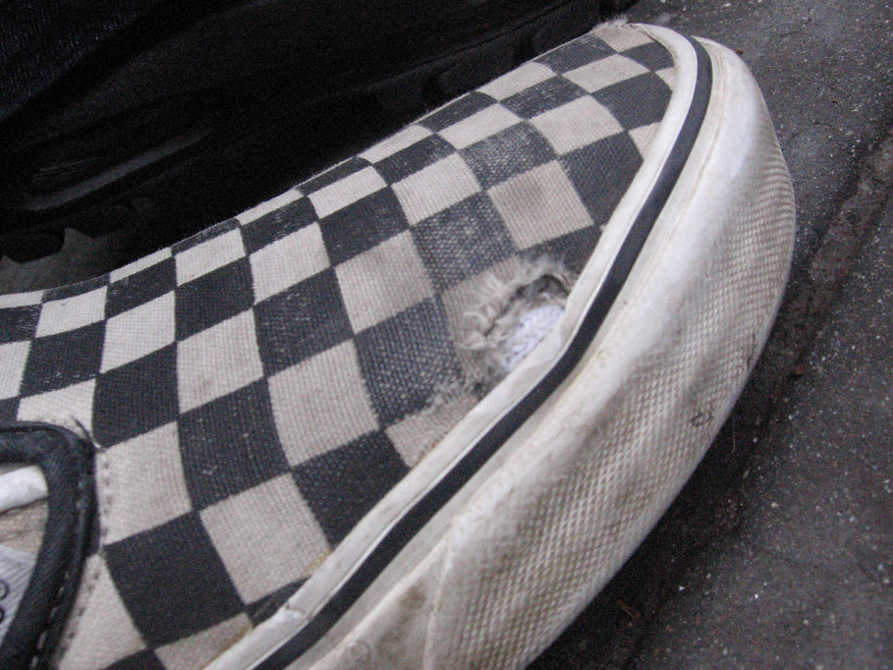
Vans on.
By: Karen, Iona, and Sasha.
The best explanation of this picture and the photo composition rule that I think best fits this picture is simplicity. I think this is an example of simplicity because it is a zoomed vision of the top of a van shoe. The picture blocks out everything thing and focuses on the shoe itself. This picture has no moon. No feeling can be produced by just looking at this photo.

