Antoinette Metoyer Art 802 05/23/08 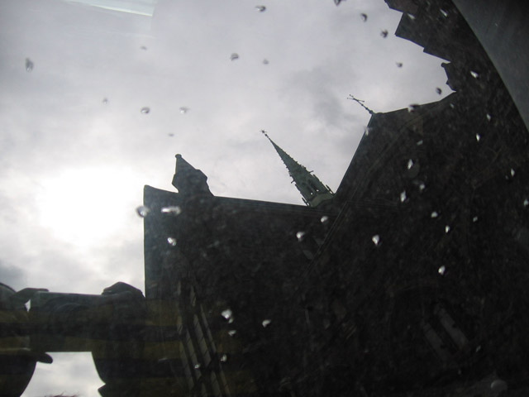photo by Antoinette I think this photo shows contrast because of the dark color church against the light colored sky. This picture is also a photo of reflection. This is the reflection of the church, sun, and sky in a car’s windshield. The mood of the photo is dark and scary. 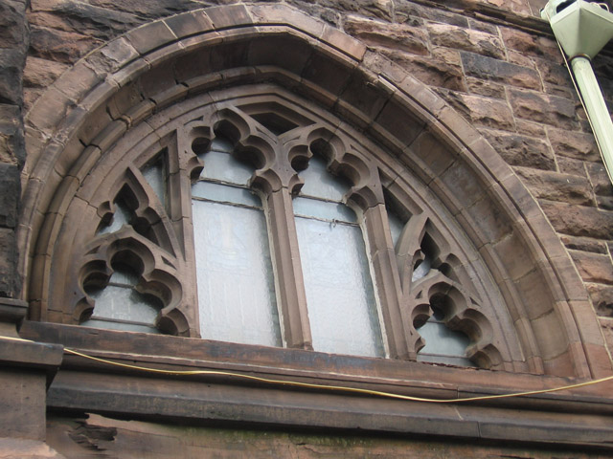 photo by Antoinette This photo shows symmetry because if you cut the photo in half, both halves would look the same.
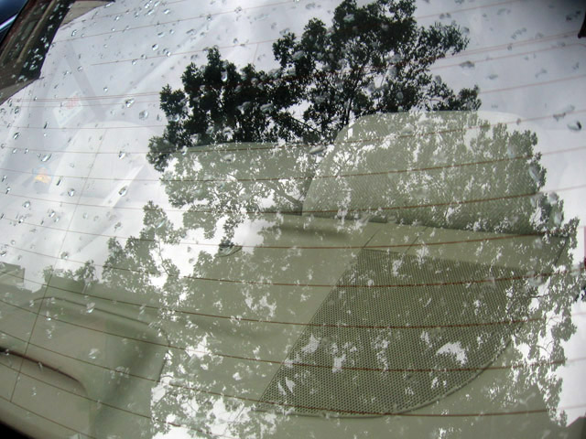
photo by Antoinette This picture is a reflection of a tree in a car.

