

Broadway Bound Books

Roza Ng
rozang123@yahoo.com
M.S.131
100 Hester Street
New York, NY 10002
(212) 219-1204

For more information, contact:
Teachers Network
IMPACT II Program
Attn: Peter A. Paul
285 West Broadway
New York, NY 10013

(212) 966-5582 Fax: (212) 941-1787
E-mail: ppaul@teachersnetwork.org
WEB SITE: www.teachersnetwork.org

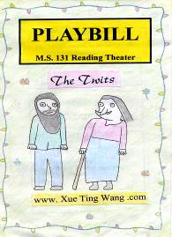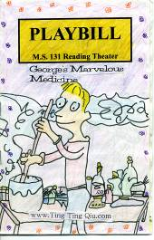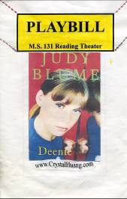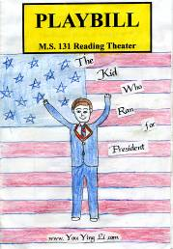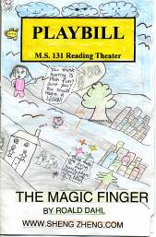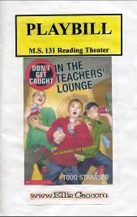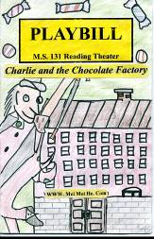

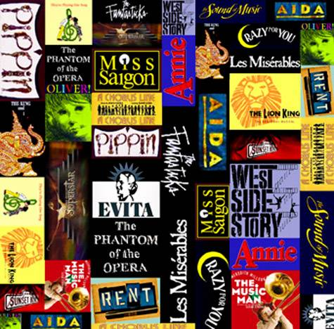

Table of Contents

Program Outline and Overview……………………………….2
Major Goals………………………………………………3
Target Student Age/Level…………………………………5
Timeline…………………………………………………...5

Lesson Plans…………………………………………………….5
Lesson 1: Reading and Writing Book Reviews……....6
Lesson 2: Learning the Main Parts of a Publication…. 7
Lesson 3: Setting, Plot, and Theme…………………...9
Lesson 4: Critic’s Corner………………………….…11
Lesson 5: Who’s Who in the Cast…………………...13
Lesson 6: Advertisements…………………………....15
Lesson 7: Layout and Illustration… …………………16
Lesson 8: Oral Presentations…………………………17
Lesson 9: Publishing Party……………………..……19
Lesson 10: Evaluation…….…………………….……..21

Appendices……………………………………………………..22
Appendix I - Illustrations and Layouts………………….22
Appendix II - Reading and Writing Book Reviews…….23
Appendix III – Describing a Character……………...…..24
Appendix IV – Character Analysis………………….…..25
Appendix V - Literal and Figurative Language…….……27
Appendix VI – Themes………………..………………...28
Appendix VII - Checklist………………….…………….29
Appendix VIII - Evaluation Form……………………….30
Appendix IX - Sample of Student Work…….……….….31

Program Outline and Overview

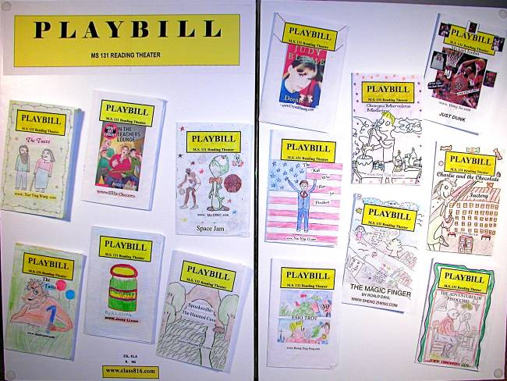

Project Description and Outline

Broadway Bound Books allows students to exercise and integrate many different skills in one project. Students select a book that they enjoy reading, then write, publish, and present a written program for that book as if it were a Broadway play. This program follows the format of a Broadway Playbill. The students have to plan for a publication by extracting the information from the book they read. The teacher presents a sample publication and discusses the parts with the students. Students are given a guide to analyze their book by stating the themes, settings, and plots of the book.

The Critic’s Corner helps students form opinions of the book and share their impressions in writing. In class, they learned the figurative and literal languages such as simile, metaphor, hyperbole, alliteration, pun, oxymoron, personification, idiom, and onomatopoeia. They have to look for these literary elements in the book and provide examples of them.

Who’s Who in the Cast enables students to analyze and critique the main character, the supporting characters, and the antagonists and the protagonists of the story.

Advertisements are created and drawn in the back of their Playbill. This encourages students to exercise their creativity. They study the strategies of advertisements by researching them in magazines and newspapers. This gives them a chance to use their persuasive and creative skills.

Presentations of their publications are made orally to other teachers and classmates to practice their presentation and public-speaking skills.

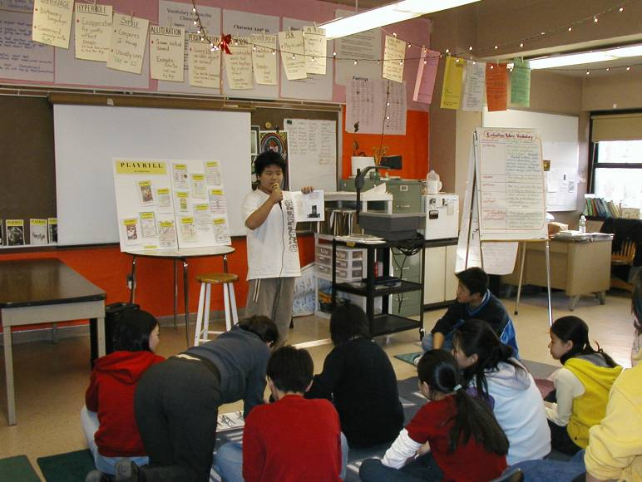

Evaluations are made following the presentations. The students evaluate each other by filling out an evaluation form in a positive tone to encourage and praise their efforts for future improvement.

Major Goals:

The program encourages students to look beyond the written material and gain insight into the author’s thoughts. The program exposes them to the many steps and aspects of publishing a book, such as layout, illustration, publisher, copyright date, and other credits.

- The program helps the students meet the Language Arts and ESL standards.
- It enables them to be creative and expand their thinking.
- It helps them to formulate an opinion and support it.
- The oral presentations in front of the class gives students practice in public speaking, which will give them greater self-confidence in a positive environment.
- They create advertisements to learn communication and persuasive skills.

- Students learn to incorporate illustrations in a publication.
- They learn to critique and evaluate other students’ presentations.

This project meets the following curriculum objectives: reading, writing, organizing thoughts, editing, book reviewing, character analysis, publishing, art, advertising, oral presentation, and evaluations

Standards

Our goal is to meet the New York City Language Standards in the Limited English Proficiency class, which include the following:

- ELA Standard 1: Students will read, write, listen, and speak for information and understanding.
- ELA Standard 2: Students will read, write, listen, and speak for literary response and expression.
- ELA Standard 3: Students will read, write, listen, and speak for critical analysis and evaluation.
- ELA Standard 4: Students will read, write, listen, and speak for social interaction.

Suggested Resources

The following materials are good resources to implement this project:

- A collection of various Broadway Playbills

- Videotaping and playback of the presentations are important for the students’ self-evaluations. The recording of presentations can also be used for future lessons for other classes.

- To encourage different forms of creative art, a variety of art supplies should be made available: color pencils, crayons, markers, watercolors, pastels, and acrylic paint.

- Computers, printers, copy machines, and paper for inserting pictures, typing, and editing

Bibliography

- The Sweetest Fig by Chris Van Allsburg
- Pigsty by Mark Teague
- Gold Luck Gold by Janet Wong
- Poetry in Motion from Coast to Coast by Elise Paschen and Brett Fletcher Lawer
- The Panther and the Lash by Langston Hughes
- Broadway Classroom Newspaper or www.broadway.com for Broadway play reviews

www.teacher.scholastic.com/writewit
- www.indiana.edu/-wts/wts/bookreview.html

Target Student Age/Level

The sixteen students that participated in this program were from a transitional ESL class. This unit can be adapted to students in 4th to 9th grades at any levels and can be used with both large and small groups.

Timeline

This unit can take up to four weeks with the class meeting for one forty-five- minute period every day. This duration can be adjusted according to the progress of the students. Generally, we completed one lesson plan per period. Other periods were focused on independent reading, writing, editing, illustrations, and practicing presentations.

Lesson Plans

The lesson plans are listed in the order of completion. A fifteen-minute mini-lesson was taught in the beginning of each period. After the mini-lesson, a related activity was assigned to the students. Each lesson was designed to be completed within forty-five minutes. The sequence of the lessons follows a logical order for the completion of the program.

Lesson 1: Reading and Writing Book Reviews

Goal:

To understand what a book review is.

Objective:
- Students learn to read different types of reviews.
- Students learn to understand the purpose of book reviews.
- Students learn how book reviews are structured.

Materials:
- Book and movie reviews from newspapers and magazines
- Overhead projector and transparencies

Procedure:
- Teacher reads a sample book review from a newspaper or magazine to the class (from overhead projector).
- Teacher reads a sample movie review (from overhead projector).
- Students are asked to identify the differences and similarities between different types of reviews.
- Students identify the different parts of a review.
- Teacher hands out a graphic organizer (See Appendix II) for students to fill out.
- The class shares their ideas with each other.

Follow up:
- Students are asked to bring in a sample book or movie review from a magazine or newspaper.

Lesson 2: Learning the Main Parts of a Publication

Goal:

To get familiar with a real publication

To learn the format of a Broadway Playbill

Objectives:

To learn to identify the parts of an actual publication

To learn how the different parts are laid out and organized in a Playbill publication

To understand the purpose of the Playbill

To see how illustrations, photos, advertisement, and text are combined to create an effective publication

Materials:

A variety of actual Broadway Playbills

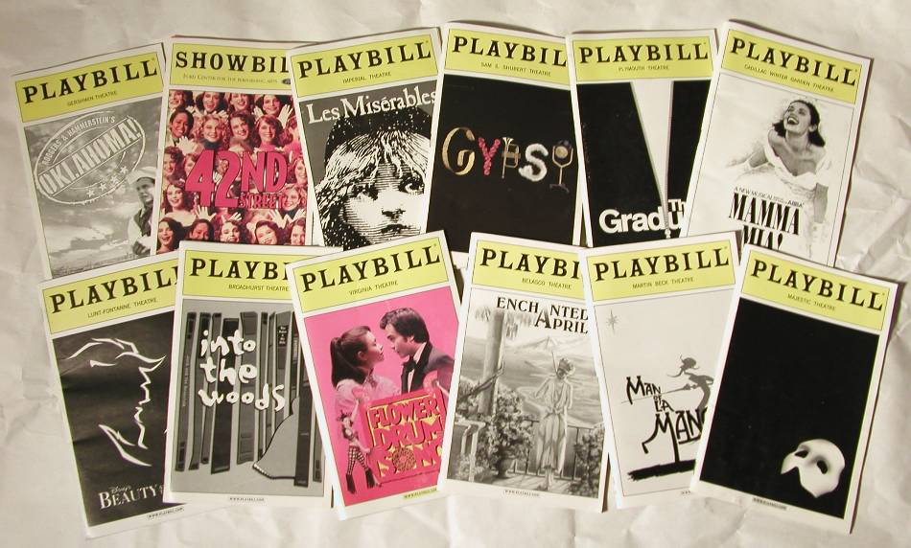

Procedure:

Students select a sample Playbill from the teacher’s collection.

Students identify the various parts of the Playbill using the graphic organizer (see appendix I).

Cover page

Credits

The setting, plot, and theme

The Critic’s Corner

Who’s Who in the Cast

Advertisements

Using their graphic organizer, students discuss and share the importance of each part.

Follow up:

Students select a book of their choice that they have read before and write a book review in the format of a Broadway Playbill.

Lesson 3: Setting, Plot, and Theme

Goal:
- To learn to understand the meaning of setting, plot, and theme

Objective:

To find the setting, plot, and theme of the selected story

To understand the importance of each part and its role in the story

To understand the main message of the story
- To learn the figurative language

Materials:

Graphic organizer (see appendix VI)

Book selected by student
- Fables by Arnold Lobel
- Overhead projector
- Teacher’s worksheet

Procedure:
- Teacher reads aloud a story from Fables and puts the story on a
transparency.
- Teacher helps students identify the setting, plot, and theme of the story.
- Setting – the background against which the story takes place.
- Plot- the information in the beginning, middle, and end of the story.
- Theme- the main idea or message behind the story that the author is trying to get across to the reader.

- Divide the class into groups of three students per group. Provide each group with a different story from Fables. Each member performs his/her own assignment.

- Student #1 will identify the setting of each scene from the story.

- Student #2 will highlight the 5 Ws (who, what, when, where, and why) in a chronological way by listing the beginning, middle, and end of the story.
- Student #3 will analyze the theme or message of the story that they read and answer the following questions: (see appendix VI)
    - Who are the main characters?
    - Are there any conflicts in the story?
    - How is the problem solved?
    - Are there any lessons learned?
    - Does the title give you any clues to the theme?

- Have group members discuss the story and share the information that they found.

- Allow time for groups to share their lists.

Follow up:
For homework, students will use their selected books to search for the setting, plot, and theme of the story.

Timeline:
1-2 weeks, depending on students’ progress

Lesson 4: Critic’s Corner

Goal:

To learn and understand critics, their role, and their critiques

To learn how to write a critique

Objective:
- To learn about facts and opinions
- To develop and express an opinion
- To learn to support an opinion
4. To learn and use figurative languages

Timeline:
- Five to ten days, depending upon class progress

Materials:
- Samples of book and movie reviews from magazines and newspapers
- Samples of Playbill’s Critic’s Corner
- Good Luck Gold by Janet Wong
- Poetry in Motion from Coast to Coast by Elise Paschen & Brett Fletcher Lauer

Procedure:
- Teacher reads aloud a book or movie review to students.
- Teacher shows samples of Playbill’s Critic’s Corner.
- Teacher gives important guidelines on how to write a book review.
  - Teacher tells students to tell the story as if they were telling their friends about it.
  - Students write a brief summary of the main points of their book, including quoting and paraphrasing key phrases from the author.
  - Students give their own opinion and feeling of the book, not just what the book is about.
  - Have students make self-to-text connections or text-to-text connection.
  - Have students identify any points in the book that are not convincing.
  - Teach students the author’s tools. (See Appendix V: Worksheet on figurative languages--simile, metaphor, hyperbole, personification, pun, alliteration, and oxymoron.)
  - Use selected poems: “I Ask My Mother to Sing” by Li-Young Lee from Poetry in Motion Coast to Coast, “Those Who Come After” by Eleanor Wilner and “Gold Luck Gold” by Janet Wong to show how figurative language is used in writing.
  - Have students work on the worksheets above.
  - Have students examine the author’s tools and give examples of descriptive and figurative language they notice from the story.

Follow up:
- Students will write their own book review in the Playbill’s Critic’s Corner format.

Lesson 5: Who’s Who in the Cast

Goal:

To learn to identify the main character’s role in the story
- To learn to identify the character traits

To form your own point of view

Objective:
- To understand the role of the antagonist and protagonist in a story
- To use descriptive language and vocabulary to describe a character
- To understand character development

Materials:
- Teacher’s Worksheets: (see Appendix III, IV, & V)
- The Sweetest Fig by Chris Van Allsburg
- Pigsty by Mark Teague

Procedure:
- Teacher reads aloud The Sweetest Fig by Chris Van Allsburg and Pigsty by Mark Teague. Teacher models a character analysis based on characters from these books for students to follow.
- Students select three main characters in their book and try to know them as they would try to get to know a friend. As they read, jot down information about them. Focus on descriptive adjectives and supporting details using vocabulary in Appendix III.
- To describe the characters in the story by using descriptive and figurative languages such as simile, metaphor, personification, hyperbole, and oxymoron. Teacher provides meanings and examples (see Appendix V).
- To introduce their characters in an interesting manner and include the following:
- Background information – name, age, home life
- Physical information – physical characteristics: tall, short, gender, appearance, etc.
- Behavior/Personality – describe their actions, likes, dislikes, fears, and dreams

- Outstanding characteristics (physical/behavioral): what is different about your character?

- Character’s impact on the plot?

How does he/she affect the story or other characters in the book?
How the character evolves in the story?
What impact does he/she have on other characters?
What was the author’s purpose for the character in the story?

Follow up:
- Follow the Playbill format on Who’s Who in the Cast- Select three characters: In sentence format, describe three main characters in the story.

- See appendix III – Vocabulary to describe characters
Examples:
He did not let his dog on the furniture, kept room clean
Examples:
When people looked at him, he thought he was being admired
Examples:
He did not want to give the painkiller to the old lady without money
Examples:
He was rich, but wanted to be the richest man in the world
Character:
Monsieur Bibot
fussy
greedy
uncompassionate
vain
Sample: The Sweetest Fig by Chris Van Allsburg

Lesson 6: Advertisements

Goal:

To learn the basics of an advertisement
Objective:
- To understand what makes a good advertisement
- To learn persuasive skills
- To learn about the different strategies and approaches of advertisements
- To become aware of the different types of ads
Materials:
- Videotape different T.V. ads
- Newspaper and magazine ad clippings
Procedure:
- Show television advertisements and have students answer the following questions:
- What is the name of the product?
- What is the product for?
- Who is the audience?
- Who are the target customers? (Age group, occupation, gender, income level, etc.)
- Were there any slogans or jingles?
- What were the key words used?
- Was it effective?
- Was it memorable?
- What was the strategy used to persuade the customer to buy the product?

- Find a printed ad in a newspaper or magazine. Have the students answer the same questions as for the television ad.

Follow up:
- The students write their own ad to sell their book using the same techniques.

Lesson 7: Layout and Illustration

Goal:
- To make an attractive publication

Objective:
- To learn about the composition of a publication
- To learn about colors
- To produce creative artwork
- To layout and organize information

Materials:
Crayons, color markers, color pencils, clipart, watercolor paints, scissors, glue sticks, bond paper

See appendix VII – Student’s Checklist

Procedure:
- Review sample Playbills
- Students sketch layouts and compose draft Playbills
- Peer reviews
- Teacher reviews and comments
- Editing of final product
- Students produce final version for presentation

Follow up:
- Students go home and memorize the different parts of their Playbill in preparation for the oral presentation

Lesson 8: Oral Presentation

Goal:
- To make a good oral presentation

Objective:
- To learn what makes a good oral presentation
- To learn how to prepare for an oral presentation
- To practice and gain experience in making an oral presentation
- To learn how to give positive evaluations

Materials:
- Completed Playbills
- List of criteria for good presentations on large poster

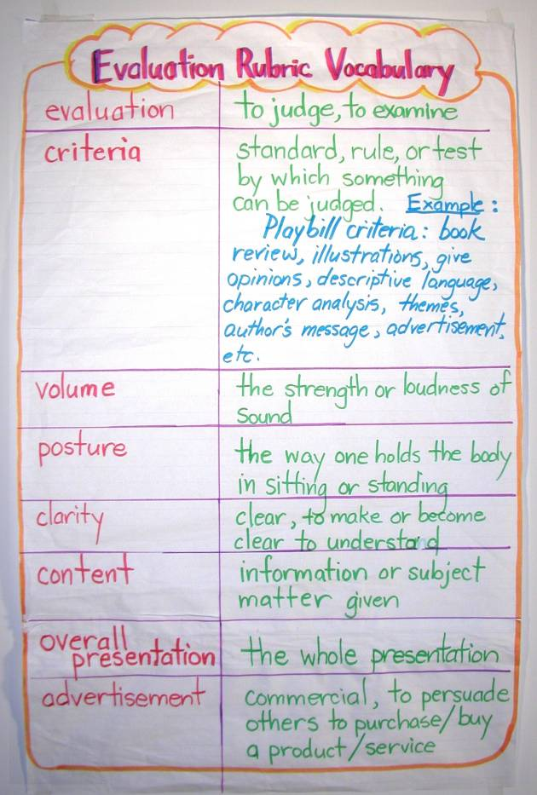

Procedure:
- Students are given a list of criteria that makes for a good oral presentation. These items are discussed in class. Examples of good presentation techniques and not-so-good techniques are demonstrated.
- Students practice and rehearse presentations with emphasis on the following:
- Practice eye contact
- Practice voice projection
- Practice good posture
- Practice speaking with clarity
- Practice giving positive feedback

Follow up:
- Students practice with peers and at home.

Lesson 9: Publishing Party

Goal:
- To prepare for a publishing party
- To prepare to give a good oral presentation

Objective:
- To make and send out invitations
- To rehearse and give a final presentation

Material:
- Computer paper, video camera, video monitor, and player

Procedure:
- Students organize their materials for a final presentation.
- Students design and make invitations to send out.
- Students make a list of invitees.
- Develop a program for students for the presentation day.
- Record their oral presentations.
- Play back and evaluate their presentations.
- Teacher shows students how to use positive feedback to encourage each other.

Timeline:
- Two days, depending on the numbers of students

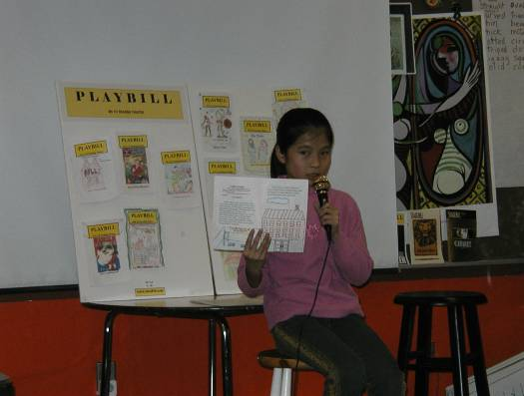 Student presentations

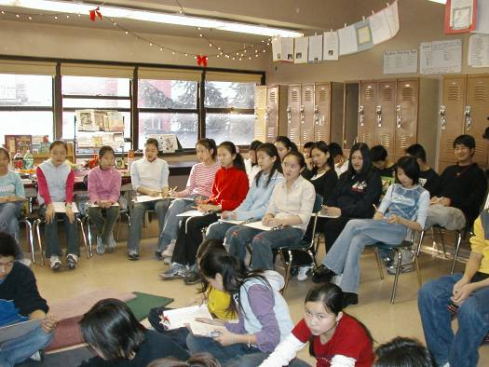 Publishing party and evaluations

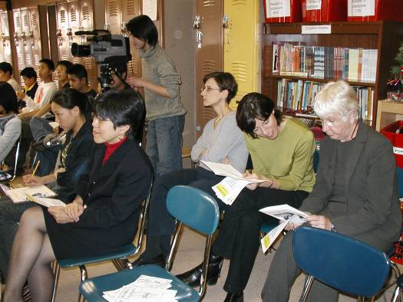 Publishing party with faculty

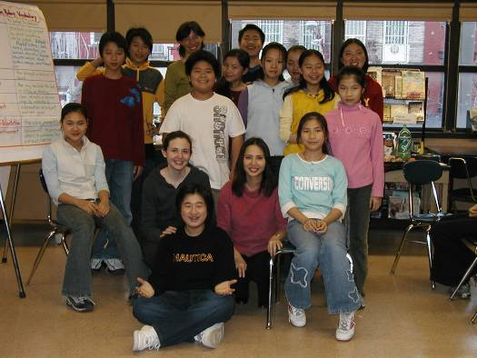 Class celebration

Lesson 10: Evaluation

Goal:
- To provide positive feedback to the students for improvement in their presentation skills

Materials:
- Completed student evaluation forms

Procedure:
- Teacher explains each criteria using large chart paper.
- Teacher explains purpose of evaluation.
- Students collect their evaluation forms from peers and assess their presentations, write their own self-improvement and reaction to the whole process.

- See evaluation form (Appendix VIII)

Appendix I – Illustrations and Layouts

Layout for a 5.5” x 8.5” eight page playbill
(Pages 5 and 6 are for continuation of page 4)

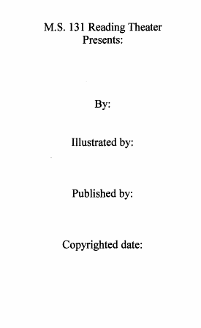
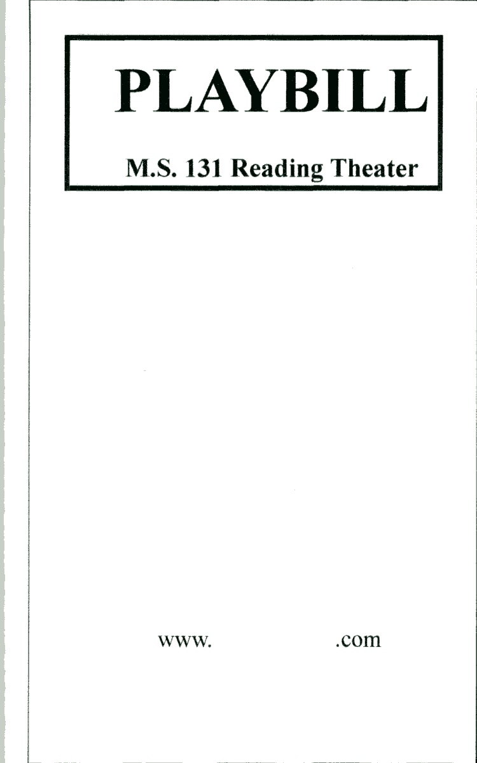
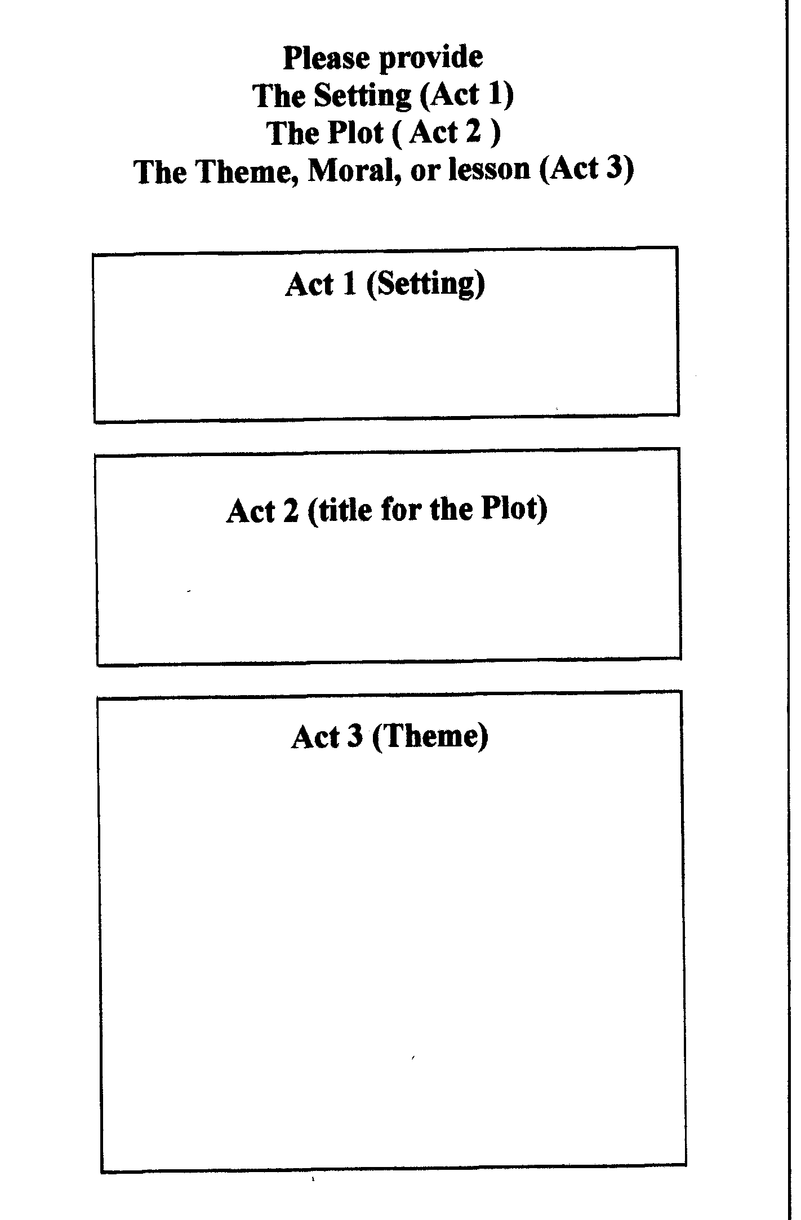
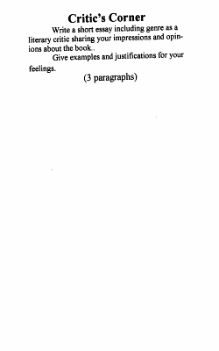

Page 1
Page 2
Page 3
Page 4

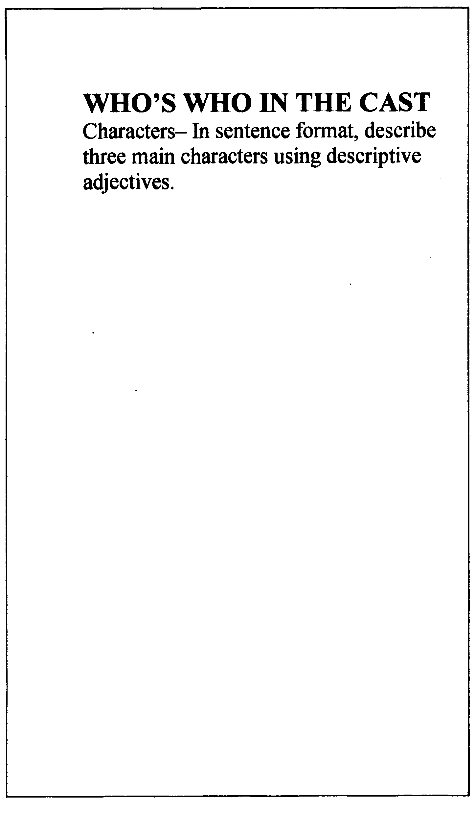


Page 5
Page 7
Page 8
Page 6

Appendix II – Reading and Writing Book Reviews

Book Review by __________________

Title: __________________________ Author:______________________
Student’s response
What is your favorite part of the book? Why?
Is the main character likeable or unlikable? Give reasons for your answer.
Was there a problem in the story and how was it solved?

What personal experiences you’ve had related to the subject?

Would you recommend this book to a friend?
How do you rate this book? Why?
**** Very good
*** Good
** Fair
* Poor

miserable, unhappy,  slow, indifferent, vain,  useless, miserly,  cheap, stingy, foolish,  thoughtless, grumpy,  frustrated, shiftless,  wavering, wasteful,  spendthrift,  upsetting, unfriendly,  difficult, dishonest,  unpleasant, bored,  irresponsible,  unreliable, stubborn,  doubtful, uncompassionate,  pessimistic, greedy | happy, ecstatic,  caring, useful,  generous, wise,  giving, thoughtful,  persistent, easy,  thrifty, clever, quick,  enjoyable, simple,  friendly, playful,  honest, truthful,  pleasant, curious,  interesting,  responsible,  reliable, eager,  hopeful, likely,  optimistic, compassionate

Appendix III – Describing a Character

Vocabulary to Describe Characters

Negative Positive

Appendix IV – Character Analysis

Describing a Character

Character number 1

Character number 2

Appendix IV – Character Analysis
(continuation)

Character number 3

Appendix V - Literal and Figurative Language

Literal language – dictionary language: concerned mainly with facts
Example: She is five feet tall and weighs ninety pounds.

Figurative language – provides word pictures

Meaning Example Student’s finding
Simile – a figure of speech in which two unlike things are compared using like or as | She is as thin as a chopstick.  He runs like a cheetah.
Metaphor - a figure of speech in which two unlike things are compared without using like or as | He was a lion in his rage.  She is the apple of his eyes.
Onomatopoeia – imitation of sound | Honk! Pow! Splash!
Alliteration – same initial sound | Peter Pan, red rose, big bug
Personification – giving life to an idea, object, or animal | The pot screamed when the tea was ready.
Hyperbole – exaggeration for poetic effect | It took him a week to find the key.
Pun - play on words | A surgeon says, “I’ll keep you in stitches.” “I scream, you scream for ice cream.”
Oxymoron – two contradictory words that come together for a special effect | Jumbo shrimp, old news, small fortune

Appendix VI – Themes

Name: _________________________ Class: ________________

Themes
- The main idea or message behind the story.
- The point about life the author is trying to get across to the reader.
- A story may have several themes.

Title of Story Theme/Message

1.
2.
3.

Appendix VII – Checklist

Name: ________________ Class: ________

Playbill Project Progress Checklist

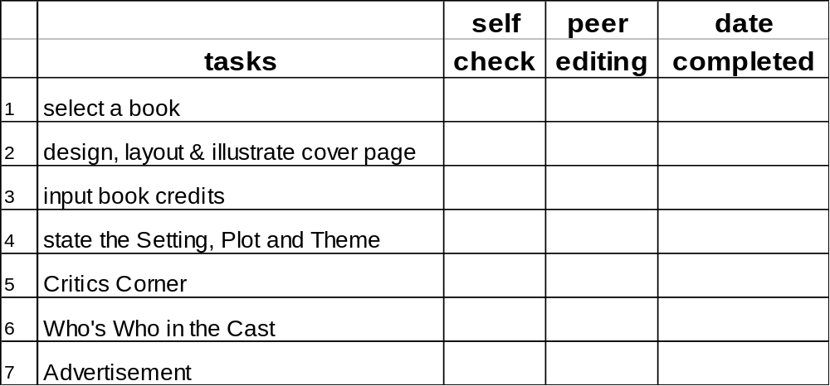

Appendix VIII - Evaluation Form

Evaluator:______________________ |  |  |  | Class:_______________
Presenter:______________________
Please circle one
 |  | needs
no. | criteria | improvement | fair | good | very good | excellent
1. | Volume | 1 | 2 | 3 | 4 | 5
2. | Eye Contact | 1 | 2 | 3 | 4 | 5
3. | Posture | 1 | 2 | 3 | 4 | 5
4. | Clarity | 1 | 2 | 3 | 4 | 5
5. | Content | 1 | 2 | 3 | 4 | 5
6. | Advertisement | 1 | 2 | 3 | 4 | 5
7. | Overall Presentation | 1 | 2 | 3 | 4 | 5

Appendix IX – Sample of Student Work

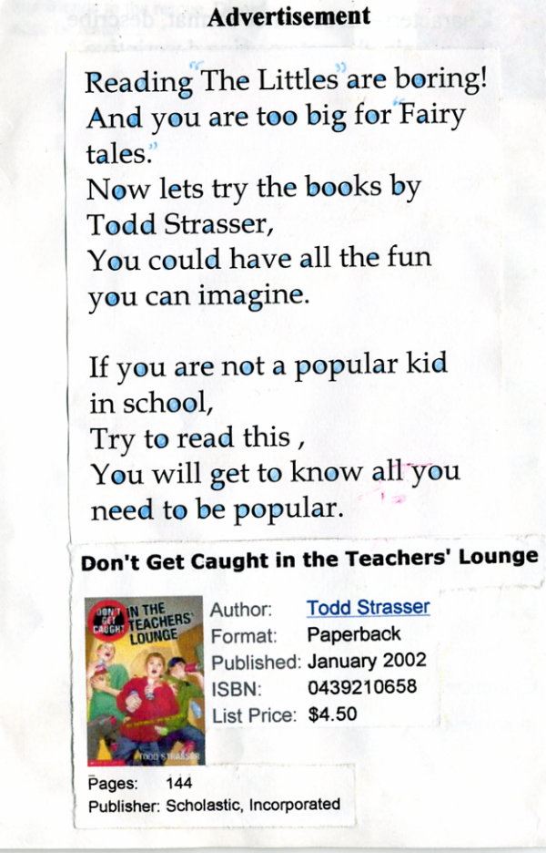
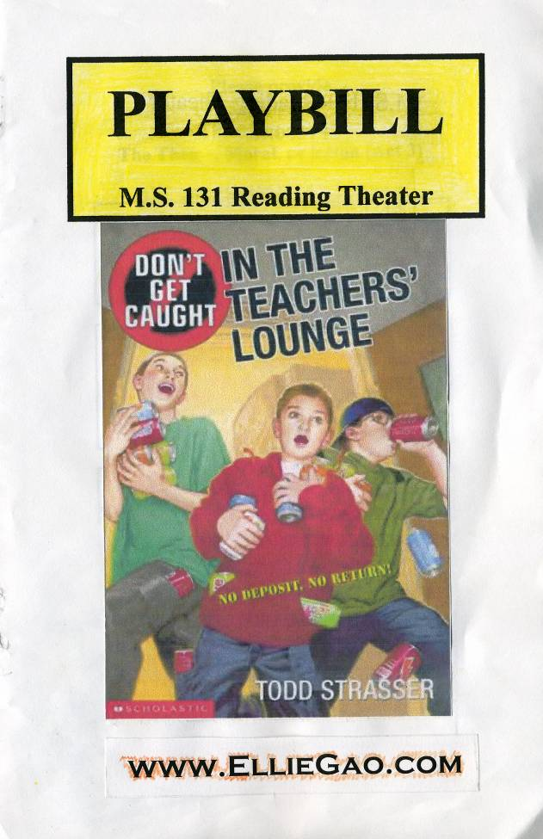

Page 1 Page 8

Appendix IX – Sample of Student Work
(continued)

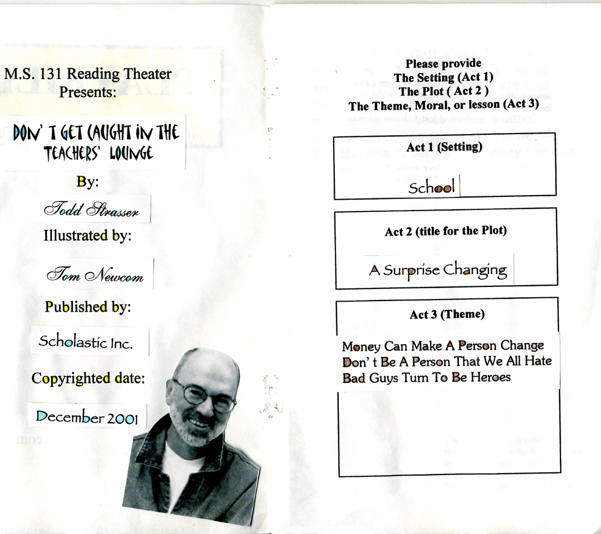

Page 2 Page 3

Appendix IX – Sample of Student Work
(continued)

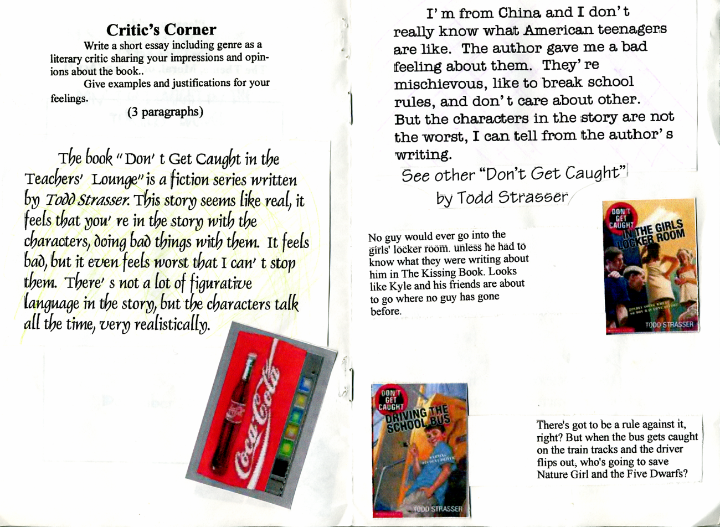
Page 4 Page 5

Appendix IX – Sample of Student Work
(continued)

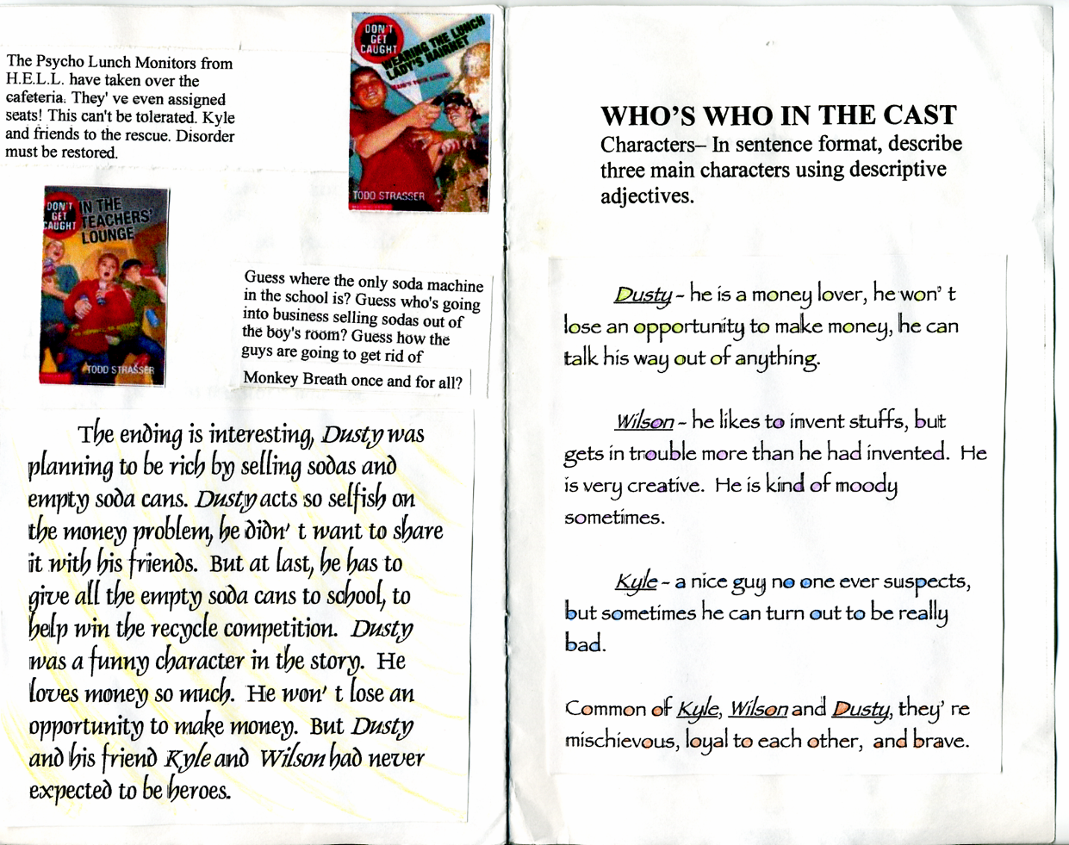
Page 6 Page 7

