Schoolyard Trees and Me!

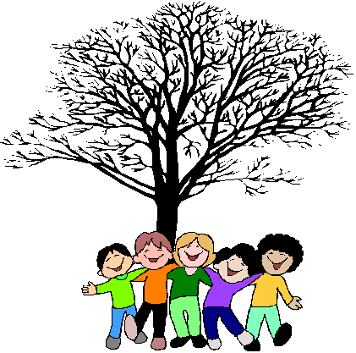

Aurora Olivieri
nyc_aurora@yahoo.com
P.S. 20
166 Essex St.
New York, NY 10002
(212) 254-9577

For more information, contact:

Teachers Network
IMPACT II Program
Attn: Peter A. Paul
285 West Broadway
New York, NY 10013
(212) 966-5582 Fax: (212) 941-1787
E-Mail: ppaul@teachersnetwork.org
WEB SITE: www.teachersnetwork.org

TABLE OF CONTENTS

Program Outline and Overview ...……………………………………………….1

Lesson Plans …………………………………...………………………………….3

Lesson 1: Embracing Similarities and Differences 3
Lesson 2: Neighborhood Nature Journal 5
Lesson 3: A Seed and Me! 7
Lesson 4: Computer Investigation 10
Lesson 5: Autumn Leaf – Print T-Shirts 12
Lesson 6: Sorting Leaves by Shapes 14
Lesson 7: Class Choreography and Performance! 16
Lesson 8: Author Study 18

Sample Worksheets …...………………………………………………………...21

Nature Journal …...………………………………………………………………………22
Parts of a Computer (1 of 2) …………………………………………………………….23
Parts of a Computer (2 of 2) …………………………………………………………….24

Resource List …………..………………………………………………………...25

Bibliography …………………………………………………………………..…26

Student Work Samples...………………………………………………………...27

Program Outline and Overview

This program uses science to connect with social studies themes and extend further into many curricular areas. It uses multi-sensory activities as students learn new things about themselves and explore their surroundings.

Children in grades K – 6 can be involved with this program with accommodations to the lessons. Older students will be able to conduct many of the activities independently and to a higher degree of detail. The author study featured in this program should be changed to fit the appropriate grade level.

A major goal of the program is to fulfill the following standards:

New York State Standards

English Language Arts
Standard 1: Language for Information and Understanding
Standard 2: Language for Literary Response and Expression
Standard 3: Language for Critical Analysis and Evaluation
Standard 4: Language for Social Interaction
Health, Physical Education, and Family and Consumer Sciences
Standard 1: Personal Health and Fitness
Mathematics, Science, Technology
Standard 1: Mathematics
Standard 2: Science
Standard 3: Technology
The Arts
Standard 1: Creating, Performing, and Participating in the Arts (Dance, Music, Visual Arts)
Standard 2: Knowing and Using Arts Materials and Resources

New York City Standards

Science
S2: Life Science Concepts
Understanding Characteristics of Organisms, Life Cycles
Mathematics
M2: Geometry and Measurement Concepts
Technology
T1: Identification and Uses of Parts of the Computer
Social Studies Core Curriculum
Myself and Others
My Family and Other Families
Time Line

This program was designed to begin in autumn with the start of the school year and the kindergarten social studies theme “Myself and Others.” Since autumn is a great time to find seeds, it presents the opportunity for seed activities. The lessons that follow can be adjusted to fit a variety of times and schedules. In my class, we study living and non-living things over the course of the year and I often vary the times for many of the lessons. We take digital photographs and assemble a PowerPoint presentation for the end of the year.

Lesson 1: Embracing Similarities and Differences

The first few weeks of school are an ideal time to set the tone for a healthy learning environment. Children are trying to introduce themselves and become members of the group. We can create an opportunity for all children to learn that in many ways we are the same and in many ways we are unique, or different. Our social studies curriculum themes begin the year with “Myself and Others.” By noticing our similarities, we can group characteristics that we share. Since we all grow and change, we can establish that we are members of the grand scheme of living things. There are many activities that children enjoy while learning about themselves and others. Graphic organizers assist in documenting and clearly defining points.

Subject Area: Social Studies

Aim: The class will use a Venn Diagram chart to show similarities and admire unique features of classmates.

Motivation: Mutual respect and team building

Materials: Basic art supplies: drawing paper, crayons, large paper or bulletin board (about 4’ x 3’), magic markers, glue or tape, scissors

Procedure:
- Choose a book to read aloud that features children and a family to raise questions about roles such as brother, sister, mother, father, etc. and list the characters in the story on a piece of chart paper.
- Ask class members to share how they relate to any character in the story by completing a sentence such as,” I am like Joe because ________________ (I live with my mom or I am a boy).”
- Pass out a piece of drawing paper to each child and ask them to fold it in half. Ask them to draw a picture of themselves on one half and a picture of their entire family on the other half.
- While children are drawing, prepare the Venn Diagram by drawing two huge overlapping ovals on large paper.
- When children are finished drawing, ask them to draw a ring around each picture and cut it out.
- Gather the group and explain that the Venn Diagram compares and contrasts information. The overlapping area of the ovals is the location for showing commonalities and the remaining sections show differences.
- Ask for volunteers to share their cutout pictures of themselves and families. Discuss things that all the pictures have in common. Someone may say that they are all people. Expand on what it means to be “people” to include the fact that people are part of a large group of living things, and living things will grow and change. Also, people live in different family structures. Some of the drawings will be of boys (sons) and others will be of girls (daughters). List a few things all children in the room have in common in the overlapping area of the diagram. (For example, we are all people, we are all living things, we are all children, we are all sons and daughters, we all have families, etc.)
- Ask two children to come up to the Venn Diagram with their cutout drawings and use tape rolled to stick the pictures to different sides of the diagram (one on each). Discuss the differences – name, hair, etc.
- Then recall the things they have in common. Talk about other areas they have in common that might be added to the center section.
- If time permits, give all students an opportunity to go to the chart as part of a pair.
- Children who are at the chart can be given the opportunity to state something they like about who they are. For example, “I like being a son.”

Assessment: Students can be lead into a discussion about how the Venn Diagram chart helps them talk about similarities and differences among classmates. The opportunity to talk about or write about the experience can assess their understanding. Also, children can work in cooperative groups using a Venn Diagram and report to the class.

Adaptations: This lesson can be easily adapted to fit any age. Similarities and differences among students can be charted to include the most basic, such as gender, family structure, homes, languages spoken, to more personality-specific qualities.

Enrichment/Extention: Students can be given the opportunity to create their own way to show comparing and contrasting data. They can design a chart or use manipulatives to show results of a class survey. To extend the activity, students can use the Venn Diagram or other graphic organizers to show information. Writing activities can easily evolve from discussion. A chart depicting quantities of characteristics can be used to develop word problems (bar graphs showing common features) and number sentences.

Home Involvement: Children can draw the members of their family and write about how they are alike and different.

Lesson 2: Neighborhood Nature Journal

Students will recall from the previous social studies lesson that we are all living things and will grow and change.

Subject Area: Science

Aim: Students will observe and distinguish living things and non-living things in the outdoor school surroundings.

Motivation: Students will make an attractive book with a fabric binding to record observations.

Procedure:
- Establish one session a week (preferably the same day and time) to go outside and explore.
- Make journals for students to record outside observations (I provide my model and easy instructions, however older children can use economical composition books by drawing a line halfway across each page and illustrate on the top portion and write on the bottom.)
- Discuss the parameters for grouping living things (including things that were once living) and non-living things. Make a chart and predict as a whole class, small group or individual, what you expect to observe that is living and non-living outside and around the school.
- Walk your students to a location outside on the school playground or in the neighborhood to observe and record. Bring crayons (each child can have a small plastic bag filled with eight basic colors) and a clipboard to draw on. Ask children to pick out something in the environment to draw and decide if it is a living or non-living thing. Look for things you can bring back to the classroom, like acorns or maple seeds, twigs, leaves, stones, etc.
- Return to the classroom and have students write about their drawings.
- Students can share their writing and illustration with a partner, small group, or with the class.
- A class chart can be constructed to list living and non-living things observed in the environment.
- Conclude by asking students to predict how the living things grow and change.

Assessment: The illustrations and journal can be an assessment of each student’s understanding of the world of living and non-living things. Children can also use magazines or newspapers to cut out pictures of living things and non-living things and glue them into circles.

Materials: Legal-size paper to make double-sided copies to assemble journals, stapler and staples, 1-inch strips of cotton fabric to use as a covering over the staples, crayons or color pencils, pencils, clipboards

Enrichment/Extensions: Students can be challenged to describe how living and non-living things in the environment interact with each other. How does a tree need non-living things (soil, sunlight, air, water, etc.)? How do animals rely on non-living things in the environment? Also, non-living materials in the environment can be explored and compared.

Home Involvement: Children can keep a journal at home similar to the one in school where they can record observations about living and non-living things in the home and surroundings.

Adaptations: Nature journals can be adapted for any age or level. Older student can be expected to begin grouping living things into plant and animal kingdoms.

Lesson 3: A Seed and Me!

Students have been observing living and non-living things in the environment. Living things grow, change and reproduce. If the class has collected seeds on neighborhood nature walks, these can be used to introduce the next lesson. If not, bring in seed pods or large dry seeds of trees (like an avocado or peach pit).

This lesson will likely span more than one class period. Seed growth will be observed over time (a least one week) and the seed-shaped books children make will be completed over time.

Subject Areas: Science and Language Arts

Aim: Students will observe growth and development of real seeds and discuss how different plant parts help them to survive. Also, they will compare seedling growth to their own growth.

Motivation: Student work will be assembled onto a hall bulletin board. The students will eventually take home seed-shaped books describing their growth over the school year.

Procedure:
- Assemble students into 4 or 5 groups and arrange desks to form tables.
- Give each group a small bowl full of mixed seeds. Try to include interesting seeds like avocado and peach pits, acorns, seed pods from honey locust trees, mixed dried beans, popcorn kernels (health food stores that sell beans and popcorn in bins are great) and give them about five minutes to handle and observe the seeds with magnifying glasses.
- Now collect the seeds and pass out a small bowl of only one kind of seeds to each group. I usually use large lima beans and fava beans, kidney beans, popcorn kernels, black beans, or garbanzo beans.
- Ask students to explain what seeds need to grow. Make a chart to record their responses (e.g., water, sunlight, dirt, air).
- Explain to students that they are going to have the chance to watch seeds germinate (begin the growth process) by using clear cups and paper towels. (I have found that industrial style brown paper towels work very well – they are sturdy and very absorbent.) Pass out one cup per group that contains a damp paper towel ready to hold seeds. Ask each member of the group to use a pencil or Popsicle stick to create a space for a seed to be placed in the cup. (Choose completely clear plastic cups for viewing or you can use clear plastic sandwich bags with paper towels.)
- Choose a place in the classroom where all seed cups can be placed together and spray the inside of the cups every day or as necessary to keep them moist. Each day give students five or ten minutes to observe the growth of seeds. Compare the seed growth in the various cups and discuss the observations of the way all seeds in the cups grow – roots go down and stem and leaflets grow up. Give students the opportunity to explain how plants grow. Discuss the functions of roots, stems, and leaves. You may also want to plant a seed from each group in a pot with soil.

The next part of this lesson is language arts. It can be continued right after the science lesson or later in the day or even days later.

- As the seedlings grow, ask students to talk about how living things grow and change. Then ask how they expect to grow and change this year. Compare and contrast children’s growth with that of a seedling they have observed.
- Have booklets prepared in advance that are made from construction paper shaped like a seed. We use the acorn shape–brown bottom and light brown top–and three or four pages of Manila paper and have each child glue a photograph of him/herself on the front. We take digital photos of the children during the first week of school. Children can decorate the book cover and write their names on the top or cap of the acorn. If you have given children decorations to glue onto the cover (like yarn, fabric scraps, shapes, or other things), you will need to let the covers dry before going to the next step.
- As a group activity (or center activity), have students turn the book to the first page and draw a picture of themselves on the first day of school and write a sentence about the beginning of school. We encourage any attempt at writing in kindergarten and then later ask students to dictate what they wrote while we write the sentence using standard spelling. We read the standard-spelling sentence with each child.
- Booklets are posted on a bulletin board with a large tree in the center. We also take digital photos of the process of seed observing and add them to the display.

Assessment: The books children create will express their understanding of how plants grow and change and how we grow and change.

Materials: Digital camera, color printer, construction paper, white or Manila paper, assorted seeds

Enrichment/Extension: Groups can compare the growth of seeds within the group as well as compare group to group. A chart can be used to show growth. Seeds can be sprouted under different conditions such as without light, creating cold or warm conditions, adding sugar to water, adding salt to water, etc. Children can paint a large tree on newsprint and later draw and cut out a crayon drawing of themselves to glue next to the tree. They can write a sentence or two about how they are like a tree.

Home Involvement: Children can do a seed search in the kitchen (with parents). They can also ask parents to share recipes made with seeds with the class (a recipe book can evolve).

Adaptations: For older students, seeds can be measured and weighed. Seed growth can be measured and charted.

Lesson 4: Computer Investigation
(This lesson will take two periods)

Subject Area: Technology

Aim: Students will identify the major parts of a computer by name and be able to discuss the use of a computer for accessing information and pictures.

Motivation: Children will observe a teacher using the World Wide Web to access information about trees to match the leaves found on the playground and in the surrounding neighborhood. They will also have the opportunity to assist during the demonstration and use the mouse to move the cursor.

Procedure:
- Divide the class into small groups by randomly passing out small pictures cards (or any other method), four of each, that are printed on different-colored card stock paper with illustrations: monitor, mouse, keyboard, and computer case. Have a box or folder available with real (fresh or dried) flat leaves collected from the schoolyard or surrounding area. We have plentiful ginko, red maple, and pin oak.
- Have one group at the computer and have others working in centers (activities in centers can tie into the computer lesson). Students at the computer are given clipboards with a labeled picture of the computer station to use as an introduction.
- Invite each student to locate one of the parts of the computer that matches a part in the picture on the clipboard. Talk about the names of the parts that are in the picture.
- Explain to students that the Internet is a service that uses a telephone line to reach information that has been set up to help others, or to purchase a product. Demonstrate going to the Internet by opening a web browser. Explain that going to the Internet is like going to the library. A web browser is like a card catalog box or a librarian helping you find the information you need. Choose a search engine that is designed for children’s use. Talk students through the process of finding sites that will have tree identification and photos. For example, I went to Yahooligans. Try to find a site that contains information about the leaves collected from your neighborhood.
- After children have watched the process, allow each child the opportunity to sit at the computer and move the mouse, point, and click.
- Move the groups through one at a time--each group should be at the computer for only about 10 minutes each.

Assessment: Make an additional copy of the sheet with the computer parts, only this time white-out the names of the parts. As a whole-class activity, children can listen for instructions such as “Color the monitor blue; Next, color the mouse red; etc.” Children can also work with a partner and bring that partner to the computer to talk about the parts. You can also have children draw their own computer and label the parts.

Materials: Computer with Internet connection (not a laptop), access to a photocopier, card-stock paper, dried leaves from the neighborhood (pictures, shapes, or cut out shapes of real leaves will do)

Enrichment/Extension: Children can work in pairs and be guided through using the Internet to further study other topics. Students can participate in these group demonstrations, which further detail parts and uses of the computer.

Home Involvement: Students can be expected to show their family members the parts of a computer using the diagram sheets or on a real computer.

Adaptations: If there is not a computer in the classroom, perhaps your school has a computer lab or a computer available in the library to use. If there are no computers available, bring in a good photograph (magazine ads or stores that sell computers can provide these) of a computer and do the lesson without the Internet component at a table. Older students can be challenged to research the names of trees in the neighborhood, how urban trees are chosen, how urban trees are adapting, and the story of the ginko tree (it was though to be extinct and then was discovered in Asia) as well as other information pertaining to trees in the city.

Lesson 5: Autumn Leaf – Print T-Shirts

This activity requires one adult to work with a small group of children (2 or 3). If you can get parent volunteers, you can have two or three groups working simultaneously. In our classroom, we have a paraprofessional who usually does this activity with a small group of children. During the past few years, we have also been lucky enough to have college and high school students who have done a great job taking over the leaf-printing portion of this lesson. It is important that they and the children wear smocks that cover a large portion of their clothing because the paint used is non-toxic acrylic and will stain if it is not washed out immediately (while it is still wet).

Subject Areas: Art and Language Arts

Aim: To create art using leaves for printing designs on shirts. Students will understand and use the elements and principals of color by mixing primary colors to make secondary colors.

Procedure:
- Collect leaves from the schoolyard, take a short neighborhood walk with students around the school, and ask them to bring in autumn leaves from home. (Make sure they pick up leaves that have fallen instead of picking them off the tree.) Store the leaves in airtight containers and spray them with water if you are not ready to use them for a day or two.
- Choose three leaves that can be easily identified by you and students (we almost always use gingko, pin oak, and red maple) and keep the rest in the science center. To identify the leaves, use a tree guide or the Internet, enlist the help of other teachers and administrators at school, check with your local park ranger or botanical garden, or ask parents and family members of students. Ask students to recall the names of leaves.
- Divide students into groups of three and set up centers or activities for small groups who are not working on the leaf printing.
- Spread and tape down newspaper on a table and set up paints along with the alphabet sponges for the words “fall” and “autumn” in a tray or container. Also, reserve some newspaper and put one or two pieces inside each t-shirt to keep the paint from seeping through to the back of the shirt.
- Engage children in conversation about the seasons. We usually ask them to name the seasons and talk about the weather and proper seasonal clothing. Ask each student to choose between printing the word “autumn” and “fall” on his or her shirt.
- Students can use paintbrushes to apply paint to the sponges. We usually use only red and yellow paint for this activity – it yields orange when the two mix and this is very exciting for kindergarten students. After the face of the sponge is covered with paint, press it gently on a piece of extra newspaper to see how it will look on the shirt. Then decide together where the word will look best on the shirt. Continue to print the word.
- Have children choose two or three leaves to use for printing. Have them paint the back of one leaf with red and yellow. (They should also apply paint to the stem.)
- Have children choose a spot for printing and gently lay the painted side of the leaf down on the shirt. Take a piece of scrap newspaper and place it over the leaf to cover it completely and ask children to run their hand gently over the newsprint. Take off the paper and carefully peel off the leaf starting with the stem.
- Repeat this with different leaves. (We usually only have time for children to do 4 or 5 leaf prints on the front of the shirt.) Talk about the primary colors -- red and yellow -- that have mixed together to create a secondary color -- orange).
- Let the shirts dry and take out the newsprint.
- Have students wear the shirts on a trip to a botanical garden, museum, or park!

Assessment: Students can recreate the mixing of primary colors to make secondary colors in a painting. They can also experiment with other objects that can be used for printing on fabric or paper.

Materials: Two 8-ounce containers of non-toxic acrylic paints -- one red and one yellow, paint brushes, small shallow trays (plastic lids from large yogurt containers are fine), sponge alphabet letters, one t-shirt for each child in the class and a few extra just in case (we usually buy t-shirts on sale and average spending $1.50 - $1.75 per shirt), newspaper

Enrichment/Extension: Children can use printmaking skill as a math activity by making prints. They can print one star and then keep adding one until they reach 10.

Home Involvement: Students can be given directions to duplicate printmaking at home using water-base paints. They can also teach their family members to identify the leaves they have used for their t-shirt activity.

Adaptations: For very young children, handprints may be substituted for leaves using autumn colors. Older students can be given more independence and use leaves, bark peelings, and other natural objects to use to print and design a shirt or sweatshirt.

Lesson 6: Sorting Leaves by Shapes

Subject Area: Mathematics

Aim: To explore basic shapes in the environment and to use shapes to sort and classify leaves.

Motivation: Children will learn the names of trees in our schoolyard and use leaves to make a pattern.

Procedure:
- Divide students into small groups and give each group a variety of flat shapes to name and describe.
- Next, give groups a variety of small objects to compare to the shapes. For example, coins, pasta shapes, and beans.
- Students can spend 5 – 10 minutes comparing shapes by trying to make approximate matches. Discuss the idea that objects may not fit exactly into a shape, but come close. Visit groups and encourage them to use specific details when comparing shapes such as corners, points, curves, lines, etc.
- Collect the small objects and hand out leaves for students to compare to shapes. For example, an oak leaf might almost fit into a rectangle or oval shape, so children can experiment with approximating shapes.
- Gather the group and show them each leaf shape (we use only three different shapes) and read the common name of the tree on the back of each leaf. Use tree identification books or printed pictures or photographs to show children the tree each leaf came from. Talk about interesting facts pertaining to trees you have found. For example, one might hold up a red maple, and talk about a relative kind of maple that is used to extract maple syrup.
- Ask students to go back to working in small groups. Pass out leaf shapes cut out of paper or card stock and write the name of the tree on the back. Make sure there is one leaf for each student. Each student can be asked to hold up his or her leaf shape and describe it to the others in the group and ask the group to name the leaf.
- While students are in groups and each child has one leaf, ask them to stand up and find other similar leaves in the room.
- Give the newly formed groups a large piece of butcher paper and suggest that they draw a tree and use the leaf shapes to trace as leaves on the tree.
- Hang the trees in the classroom.

Assessment: Students can work individually and draw a tree with leaf shapes. On the bottom of the paper, each child can make shapes that are similar to the shape of the leaves and/or draw the shapes explored in the lesson.

Materials: Leaves, traced shapes of leaves cut out of paper or card stock, a variety of small shaped objects (pennies, beans, dice, pasta, etc.), butcher paper, plain paper, card stock shapes of circles, squares, rectangles, ovals, triangles

Enrichment/Extensions: Students can work as a group or individually to invent new shapes and decide on names for them. Shapes can be used to make interesting patterns on long strips of paper. The shape of the tree trunk and branches can be explored and compared to a cylinder. Students can measure the circumference of the trunk of a tree and measure the circumference of their waists and compare and contrast the two.

Home Involvement: Students can be asked to find shapes in the rooms of their homes and on the walk home from school.

Adaptations: Older students can use more sophisticated shapes and form more difficult patterns. Also, they can learn scientific names along with common names of trees. Younger children can work with larger shapes.

Lesson 7: Class Choreography and Performance!

Subject Areas: Music and Physical Education

Aim: Students will demonstrate movement elements and sing songs while dancing.

Motivation: Students will make costumes and perform in a show at the end of the school year.

Procedure:
- Choose a song that will inspire children and play it many times during snack or free play activities so they become familiar with the music. We use “Roots and Shoots Everywhere” by Raffi.
- Introduce the song by its title and talk about the tape or CD cover. Read the first refrain to the class and talk about the meaning of the song. In our case, the refrain concludes that children are the roots and shoots of the world. We give children a chance to compare themselves to trees and other living things.
- Ask children to think of dance movements that match each sentence of the refrain. For example, “roots” can be acted out by stretching and pointing toes out and back, or by squatting and letting fingers wiggle into the floor. Work through a sequence of steps by practicing in small groups and then with the whole class until everyone agrees on the sequence and movements.
- Make a chart to list the dance movements for each line in the song (some dance movements can repeat and last through several lines).
- Spend one period on the refrain and schedule one period for each verse and continue until you have a group of movements for each verse in the song.
- Keep building the chart until the song is finished.
- Children can plan a performance by making costumes. We use local leaves and make green leaf prints using acrylic paints on oversized white t-shirts and ask students to wear dark pants for the performance.

Assessment: Students will perform dances in small groups and as a whole-class activity. The steps and movements can be used to create new dances.

Materials: A song that has a theme connected to trees, leaves, growth, or living things (such as “Roots and Shoots Everywhere” from the Let’s Play CD by Raffi), a CD or tape player, one oversized white t-shirt for each student, non-toxic acrylic paint (we use white, black, and green to mix colors for a variety of “greens”), chart paper

Enrichment/Extensions: Children can write poems individually or with a small group and create movements that express or connect to the words.

Home Involvement: Students can teach a family member the dance movements. They can also have family members create a dance to a favorite song. The class can have a day when children and/or families dance.

Adaptations: Children can do this activity to music without words. They can also create poems to dance to.

Lesson 8: Author Study

Subject Area: Language Arts

We chose author Lois Ehlert because so many of her works are about plants and animals. Also, her book Red Leaf, Yellow Leaf is an introduction to the life cycle of a tree.

Biography: Information about Lois Ehlert is readily available on line. It can be obtained by a search using the author’s name or at www.friend.ly.net/scoop/biographies/ehlertlois.

Exploring the Author’s Life:
- Students can listen to the teacher read details about the author’s life and afterwards have a discussion.
- The class can dictates a time line or three-part chart to recall the author’s life as a young child, older child, and adult. Children can illustrate the details of the author’s history.
- Students can choose one thing they have in common with the author and illustrate and write about it.
- Students can predict the topic of the next book the author will write about.
- Students can each draw a picture of the author and write a sentence telling about something they like about her. These drawings and writings can be made into a book and kept in the class library or sent to the author.
- The class can relate to the author by engaging in something the author liked to do as a child. For example, Lois Ehlert enjoyed making art from wood pieces and fabric in her home. Children can build art from these materials. She also made collages from fabric.
- Students can research the place the author was born and use a map to locate it.
- Students can listen to many books written by the author and produce a written response to the book along with an illustration.
- Students can read several books by the author and/or read to a partner or family member.

Books by Lois Ehlert and Activities:

Red Leaf, Yellow Leaf
- Students can recall the life cycle of a maple tree and illustrate the cycle as a group project.
- Students can eat sliced apples dipped in maple syrup and describe the taste and texture. The apple slices can be used to talk about fractions: one half, one fourth, and one eighth.
- The class can take a neighborhood walk to look for trees in various stages of growth and notice the differences in leaf and bark color.
- The class can take a trip to a local commercial nursery, greenhouse, or botanical garden to observe trees.
- A wide variety of tree products can be explored and celebrated.
- Children can write about what life would be like without trees.

Eating the Alphabet
- Students can combine letters and fruits or vegetables and create a recipe for those letters. They can also find a fruit or vegetable for each letter of their first name.
- Students can draw a fruit or vegetable that has the same beginning sound as each letter in his or her name. For example: Bob draws a banana, orange, banana.
- Children can draw and cut out their favorite fruit or vegetable (or cut out a photograph from a newspaper or magazine) and glue it on to blank piece of drawing paper and create a person using the fruit or vegetable as the body. They can name the person and make up a story about their character.
- The class can find fruits or vegetables that no one in the class has tasted and have a tasting party.

Growing Vegetable Soup
- Students can bring in vegetables from home and the class can separate them into plant parts (roots, stems, fruits, etc.)
- The class can take a trip to the local market and purchase vegetables for soup.
- The class can take a trip to the supermarket and each child can purchase one pound of beans that can be mixed to make small packets of bean soup mix to take home.
- Kitchen fruit and vegetables can be used to grow a Kitchen Dish Garden. Plant carrot tops, dried beans, potato eyes, fruit seeds, etc.
- Bottle gardens can be made to plant herbs in clear large plastic soda bottles (cut the top off the bottle first).

Planting a Rainbow
- Students can paint a large rainbow mural on butcher paper and, after it dries, use crayons to draw flowers inside the bands that match the colors. They can also make tissue-paper flowers and glue them to the bands.
- The class can take a neighborhood walk to a local florist and interview the florist about his or her job. The teacher can ask for tiny flowers and ferns to press back in the classroom. Pressed flowers can be used to decorate cards.
- The class can plant a school flower garden or plant seeds in pots.
- The class can sponsor a plant and flower sale and donate the proceeds to a worthy cause, or use the profits for classroom supplies.
- Students can create and name a new flower using paint, tissue paper, construction paper, glue, and imagination.
- Students can make Rainbow Soup using 4 cups of chopped or sliced colorful vegetables. We use red cabbage, carrots, celery, tomatoes, snow peas, baby corn, potatoes (purple potatoes if you can find them), spring onions, and zucchini. Sautee the vegetables in about ¼ cup olive oil until they are slightly cooked. Add ½ cup water for each child. Bring to a boil and simmer for about 15 minutes. Add salt to taste. Let it sit for a few minutes before serving. Enjoy! This is a delicious soup.

Nuts to You
- Students can write about a pet they have or would like to have.
- Make a list of city animals and research their food sources.
- Students can compare the life of an animal to the life of a tree and use Red Leaf, Yellow Leaf as a study of the life cycle of a tree.
- Children can each bring in ½ cup of nuts and one fruit each. The class can make fruit salad by washing, peeling and chopping fruit and adding nuts and maple syrup. (Remember: peanut allergies are common.)
- Use nuts for sorting and making patterns in the math center.

Sample Worksheets
Nature Journal

Monitor
Mouse
Computer
Case
Keyboard
PARTS OF A COMPUTER
PARTS OF A COMPUTER
Resource List

Web Links

1. Brooklyn Botanic Garden at www.bbg.org
* Barbara Kushner-Kurland in the education department is a great resource for ideas and teacher training workshops.
2. American Museum of Natural History at www.amnh.org
3. Urban Park Rangers of Central Park at www.centralpark.org
* School programs
4. New York Botanical Gardens at www.nybg.org
5. Yahoo for Children at www.yahooligans.com
* Links to leaf identification

Equipment

Digital camera, computer, printer, Internet access

Field Trips

1. Museum of Natural History: Observe plants and animals that can be found in New York City.
2. Brooklyn Botanical Garden: Observe a variety of plant life; compare shapes, sizes, and colors of tree parts.
3. Central Park: The ecology program with Urban Park Rangers focuses on how living and non-living things interact in the environment.
4. Several walks to trees in our school neighborhood.
Bibliography

1. Ten-Minute Field Trips by Helen Ross Russell
2. Trees by Steven M. Aronson
3. The Reason for a Flower: World of Nature by Ruth Heller
4. New York City Trees, A Field Guide for the Metropolitan Area by Edward S. Barnard
5. Golden Guide to Field Identification: Trees of North America by Frank Brockman
Student Work Samples

LEAF PRINT T-SHIRTS

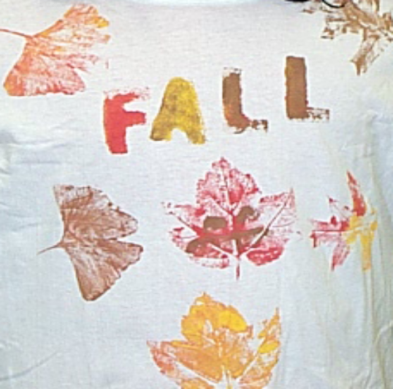

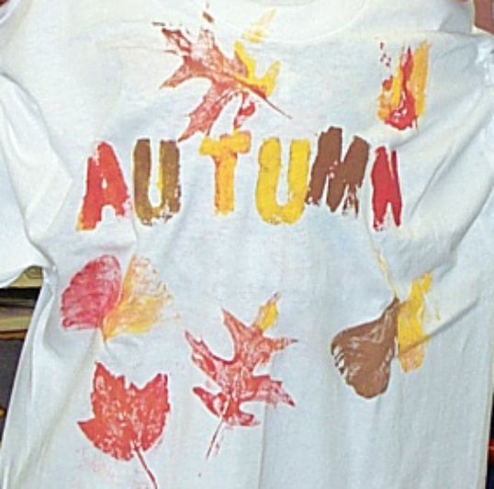

NEIGHBORHOOD NATURE JOURNAL
(Kindergarten Example)

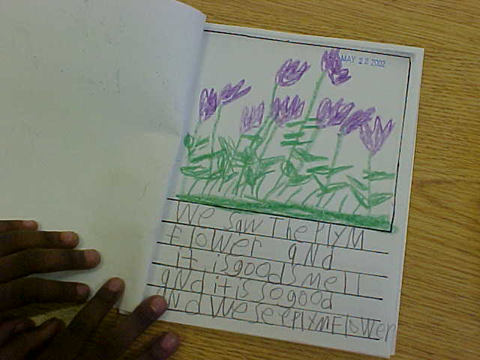
RAINBOW SOUP

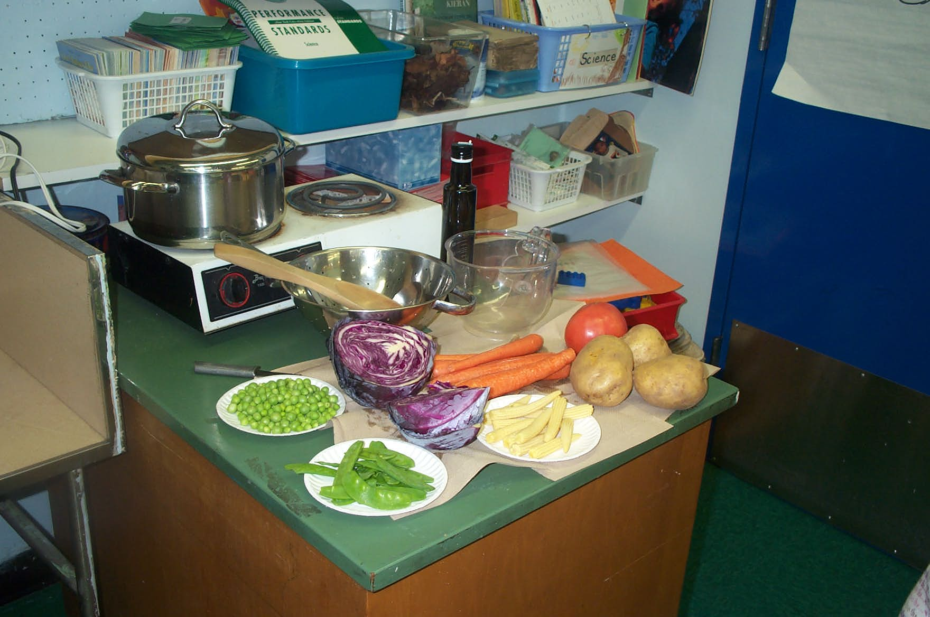
BOWL OF RAINBOW SOUP



