Photo Analysis

Procedure:

You are to pick out 5-10 of the most interesting photos that you think/feel have the best composition. Search your group’s photos first. You may use any other group’s photos as well.

After dragging your choices into a word document, you need do the following:
1. Create a title and credit the photography group for each of selection.
- Write which Composition Rule(s) is/are best illustrated.
- Write an explanation for the rule you believe the photo belongs to.
For example, if you list Contrast as the rule illustrated in a photo, you need to go into an explanation for your selection. You might then say the bright red door contrasts with the black hinges and the dull gray-brown rock surrounding it.
- Finally include any other analysis besides compositional analysis.
You may explain why it has a certain mood, or the degree of abstraction, or if it has any surreal quality and why.

By: Alexis Lamb, Jamiee Nathaniel, Art 802
And Nairobi Green May 23, 2008

- Bag In Wire
-Rule of thirds= The bag caught in the wire CONTRASTS against the dark brown background. The focal point is the bag that is two-thirds up the page.
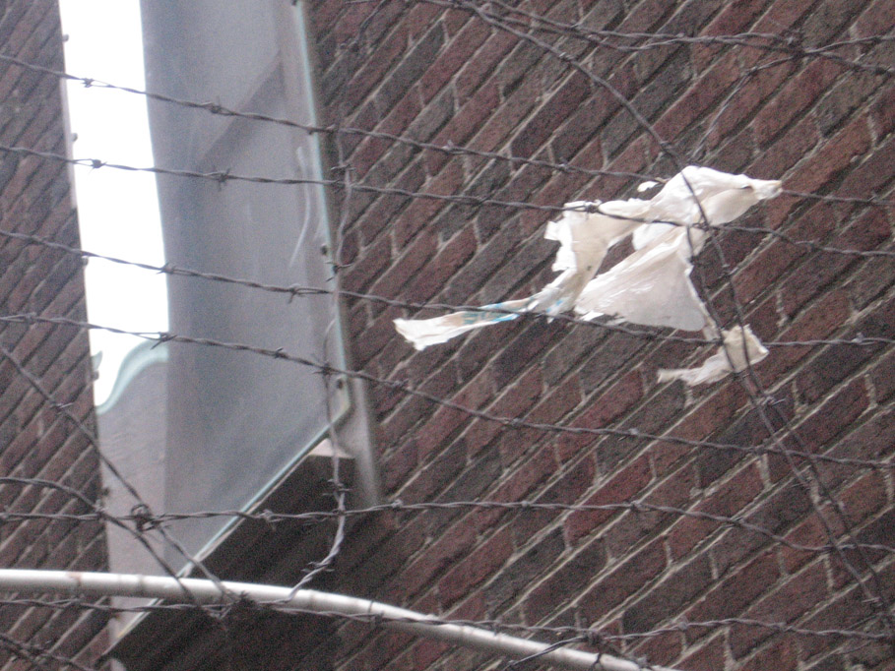

2. Feet circle
-Birds eye view- The view point of this picture is seen from a birds point of view.
-Framing- The feet form a circular shape on the sidewalk.
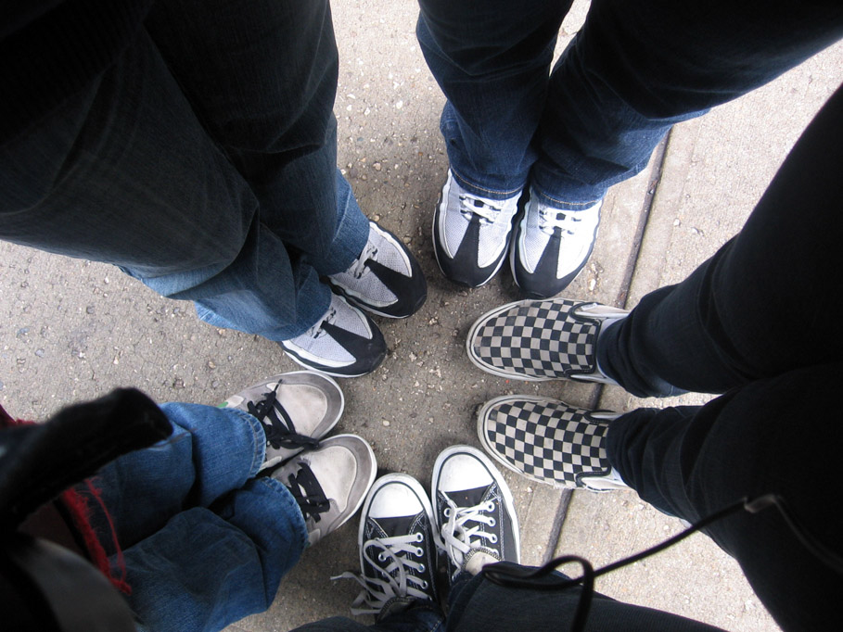

3. Feet Pattern
    - Pattern- The imprint of the feet repeat in a semi-circular motion.
    - 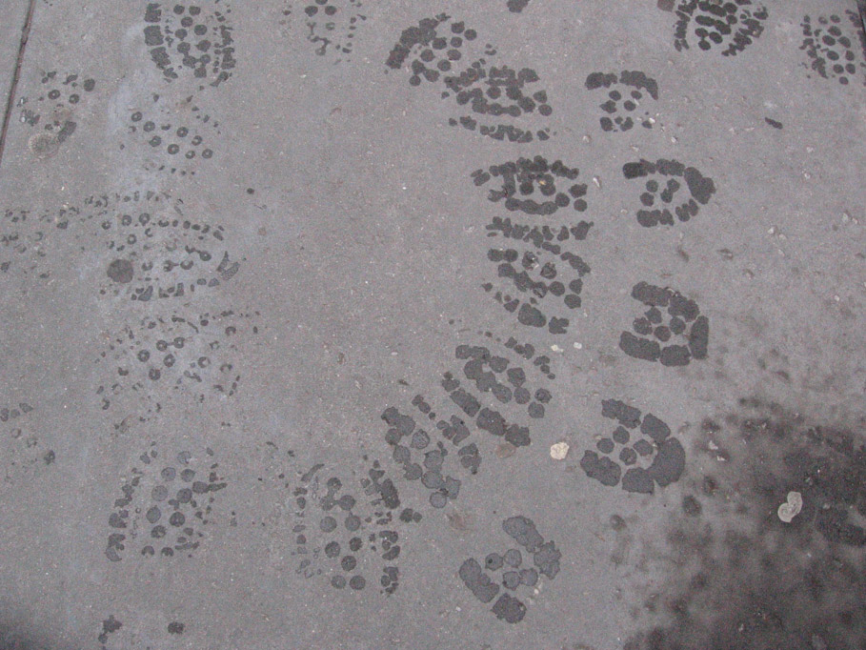

3.Pole
-Worms eye view- the viewpoint of the pole looks as if a worm is looking up towards a pole.
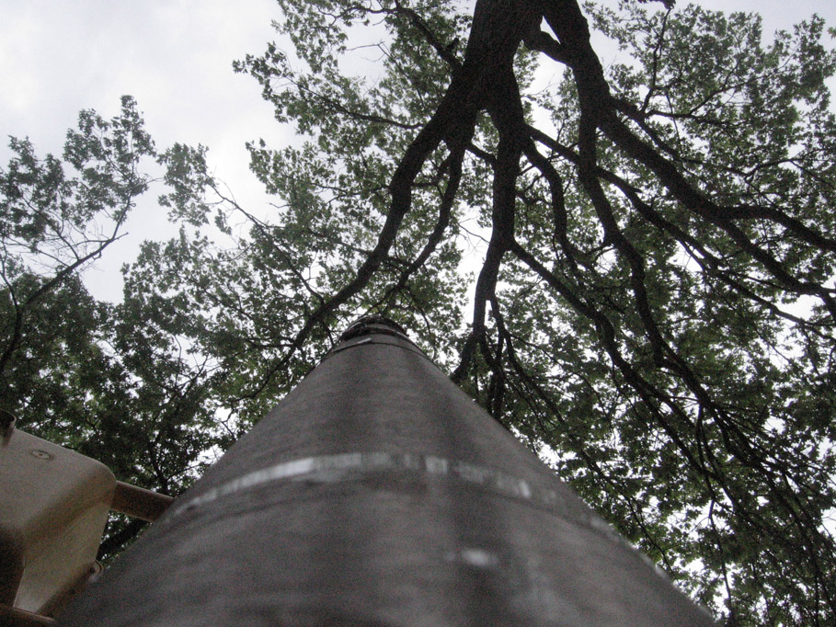

4.Pole-Forward view
-The view in this picture looks like someone is walking forwards to the people on the other side.
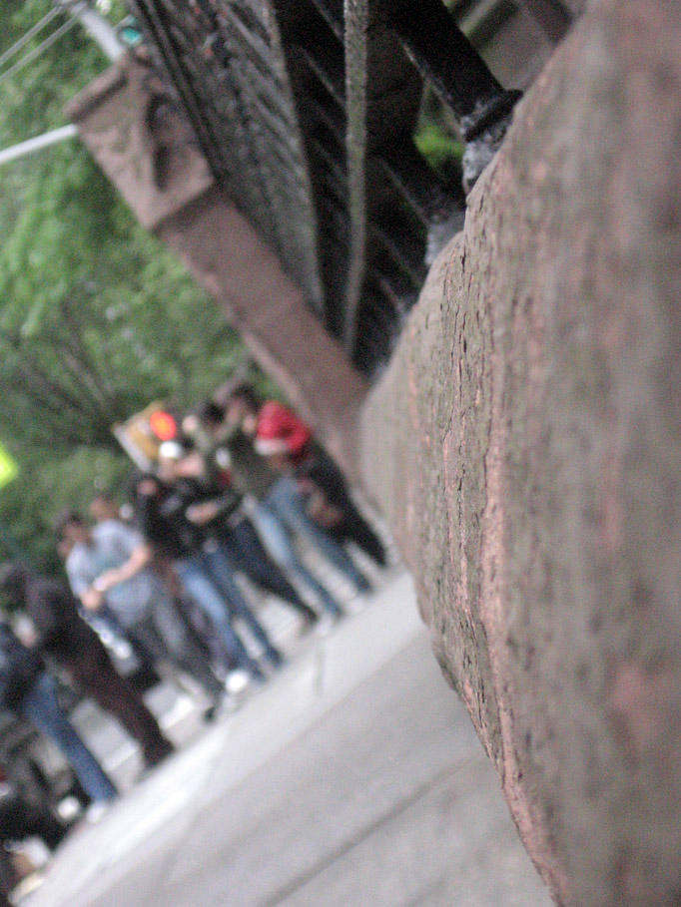

- Tree in Puddle
-In the puddle the tree and church reflects onto the water, giving you the view of the tree as if you were looking up at it.




